Sample cell phone drawing….Intro to Engineering…..Instructor A. Wilson

Directions: using the following as an example create a 6 view drawing of your cell phone

Standards

****

****



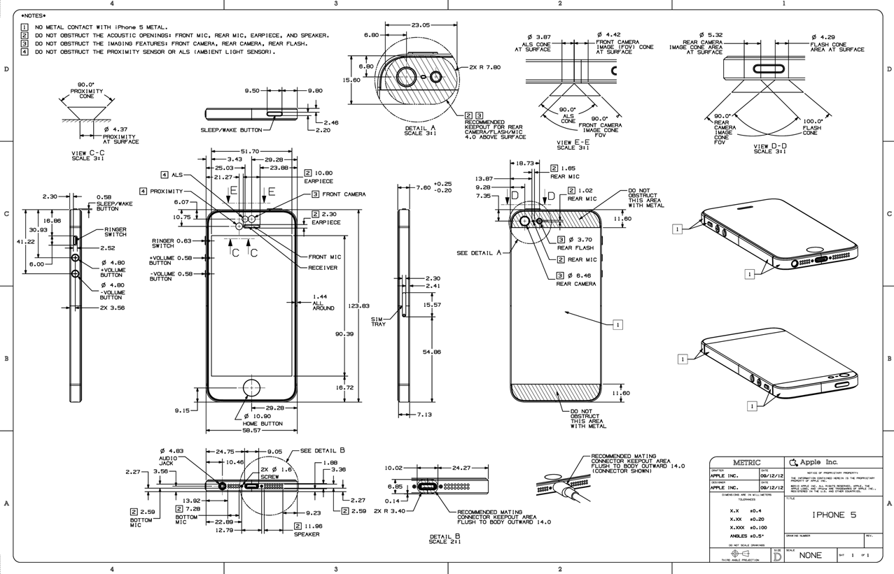

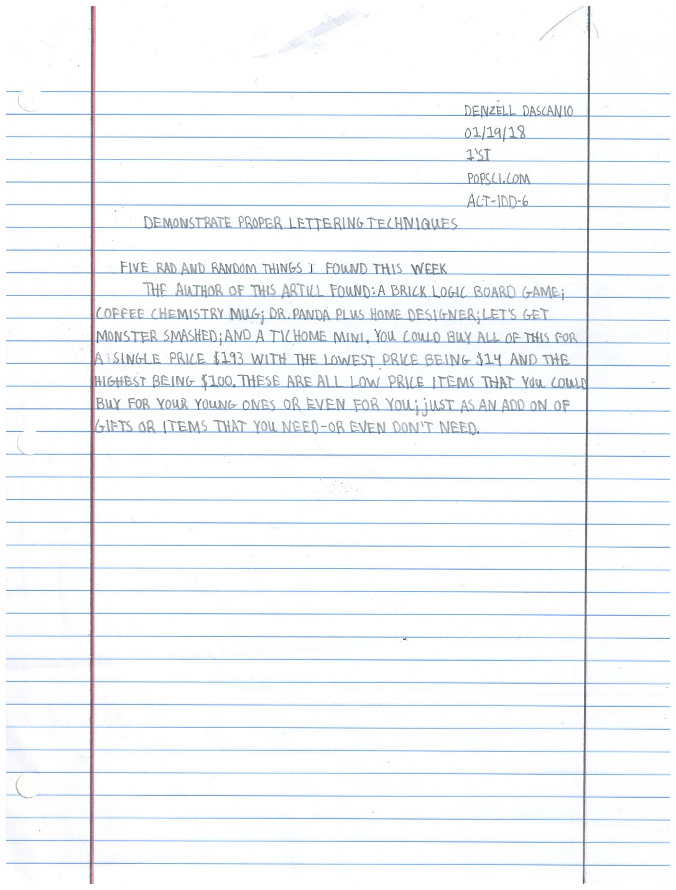

1.Name

2.Date

3.Period

4. Source of Object

Website, magazine or newspaper)

5. Standard act-idd-6

6.Title of article (student did not include title)

7. Minimum 3 sentence summary

Rules:

1. All caps
2. Text height 1/8” tall or ½ height of guide lines
3. Letters can not exceed pass boundary lines
4. No San serifs (Tops and Bottoms on I’s or J’s)
5. Due every Friday before you enter into classroom

***Design articles and Lettering Architecture and Engineering***

Instructor: A.Wilson

**Introduction to engineering Instructor A.Wilson**

**Week 2 bearing drawing 3 views**

The front view will be the view labeled with the 1.125-1.123 REAM

1. **Create the following layers**

**Object** / Color White/ Line wieght .60 mm/ Linetype Continuous

**Hidden** / Color Red/ Line wieght 0.00mm/ Linetype hidden

**Title block**/ Color Magenta/ Line weight .90mm/ Linetype Continuous

**Dimensions/** Color Green/ Line wieght 0.00mm/ Linetype Continuous

1. **Required** front, right, top view, dimensions and title block. Views must include hidden lines

(20 points per required)

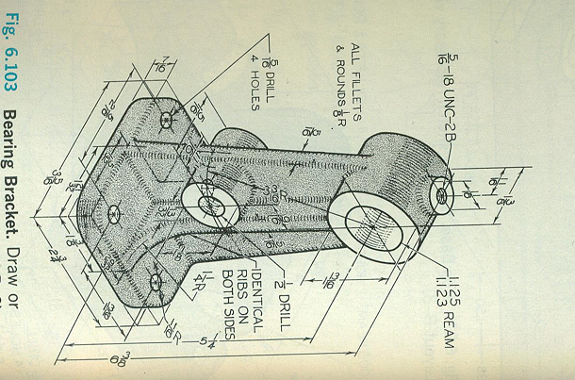

Title Block Drawing

**Week 2 Intro to Drafting and Design (A.Wilson)**

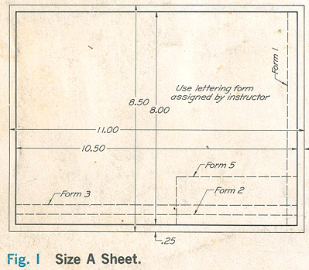**Directions: Draw the following Drawing Inside autocad. The title block will be used for the remainder of drawings for the semester. Use form 3**

**Layers**

Text/o.oo/green

Edge of Paper/o.oo/gray

Title Block box/.90/magenta

Guide Lines/0.00/gray

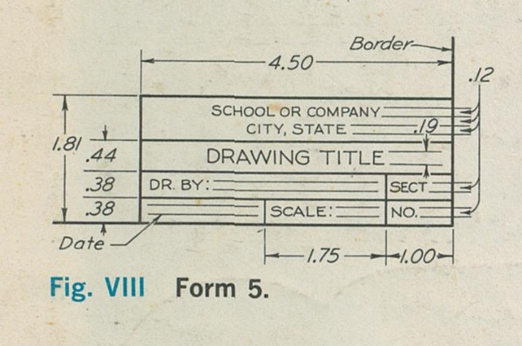

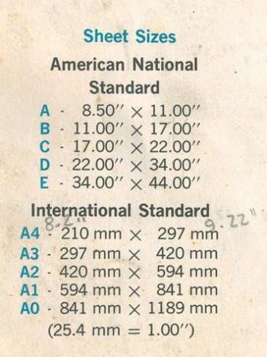

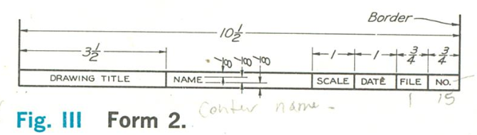

**Introduction to engineering Instructor A.Wilson**

**Week 3 Guide Base drawing 3 views.doc**

The front view will be the view as seen in the front view sketch position

1. **Create the following layers**

**Object** / Color White/ Line wieght .60 mm/ Linetype Continuous

**Hidden** / Color Red/ Line wieght 0.00mm/ Linetype hidden

**Title block**/ Color Magenta/ Line weight .90mm/ Linetype Continuous

**Dimensions/** Color Green/ Line wieght 0.00mm/ Linetype Continuous

|  |  |  |
| --- | --- | --- |
| **Required** | **Points** |  |
| Front View of Trailer | 20 |  |
| Top View of Trailer | 20 |  |
| Right View of Trailer | 20 |  |
|  |  |  |
| Title Block | 20 |  |
| Dimension | 20 |  |
| **Total Points** | **100.00** |  |

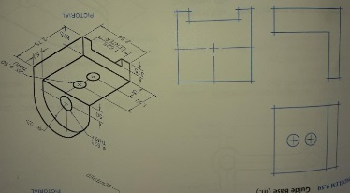

**Introduction to engineering Instructor A.Wilson**

**Week 4 Enclosed Trailer 5 views.doc**

The front view will be the view as seen in the front view sketch position

1. **Create the following layers**

**Object** / Color White/ Line weight .60 mm/ Linetype Continuous

**Hidden** / Color Red/ Line weight 0.00mm/ Linetype hidden

**Title block**/ Color Magenta/ Line weight .90mm/ Linetype Continuous

**Dimensions/** Color Green/ Line weight 0.00mm/ Linetype Continuous

1. 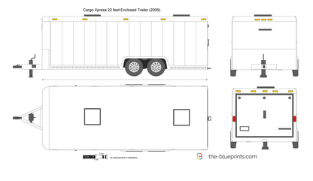

|  |  |  |
| --- | --- | --- |
| **Required** | **Points** |  |
| Front View of Trailer | 14.285 |  |
| Top View of Trailer | 14.285 |  |
| Right View of Trailer | 14.285 |  |
| Left View of Trailer | 14.285 |  |
| Title Block | 14.285 |  |
| Dimension | 14.285 |  |
| **Total Points** | **100.00** |  |

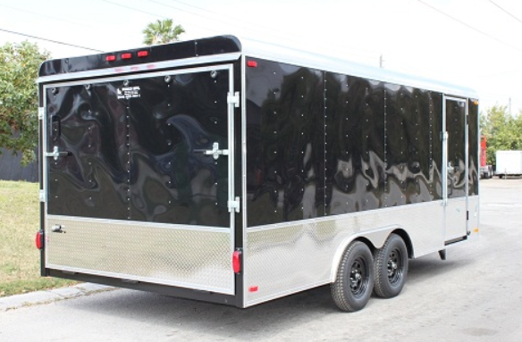 Example of completed trailer drawing below. Note views are not in correct order

1. First grade for project which will count as summative grade will only be for the boxes that the trailer will be drawn in. Students will break into teams of three. 2 people measuring and one person recording the measurements. Boxes must be in correct order and in autocad.

Good Luck.